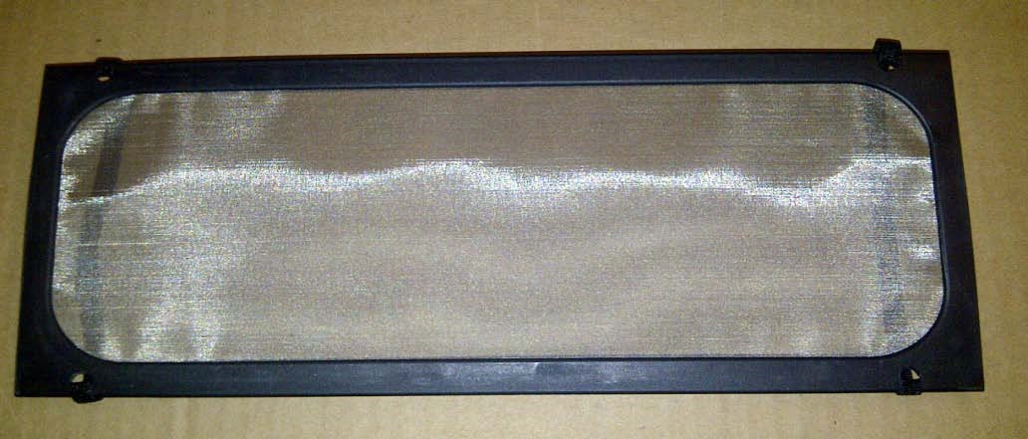

Patented Odor Remover Screen
- Remove from bag.
- Activate the by exposing to the Sun for 30 seconds.
- Wrap bands around visor (as shown below) or stick to designated area with suction cups.

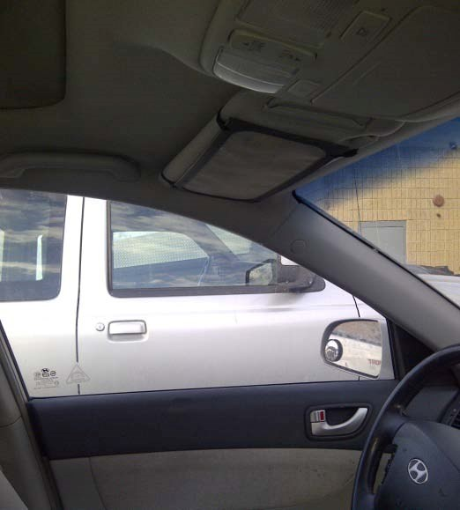
2 year lifespan!
Contact: Barb at
US Air Purifiers LLC
(d/b/a AirPurifiersDirect2U LLC)
888-231-1463 ext 1
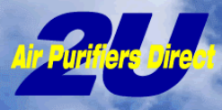 www.AirPurifiersDirect2u.com

